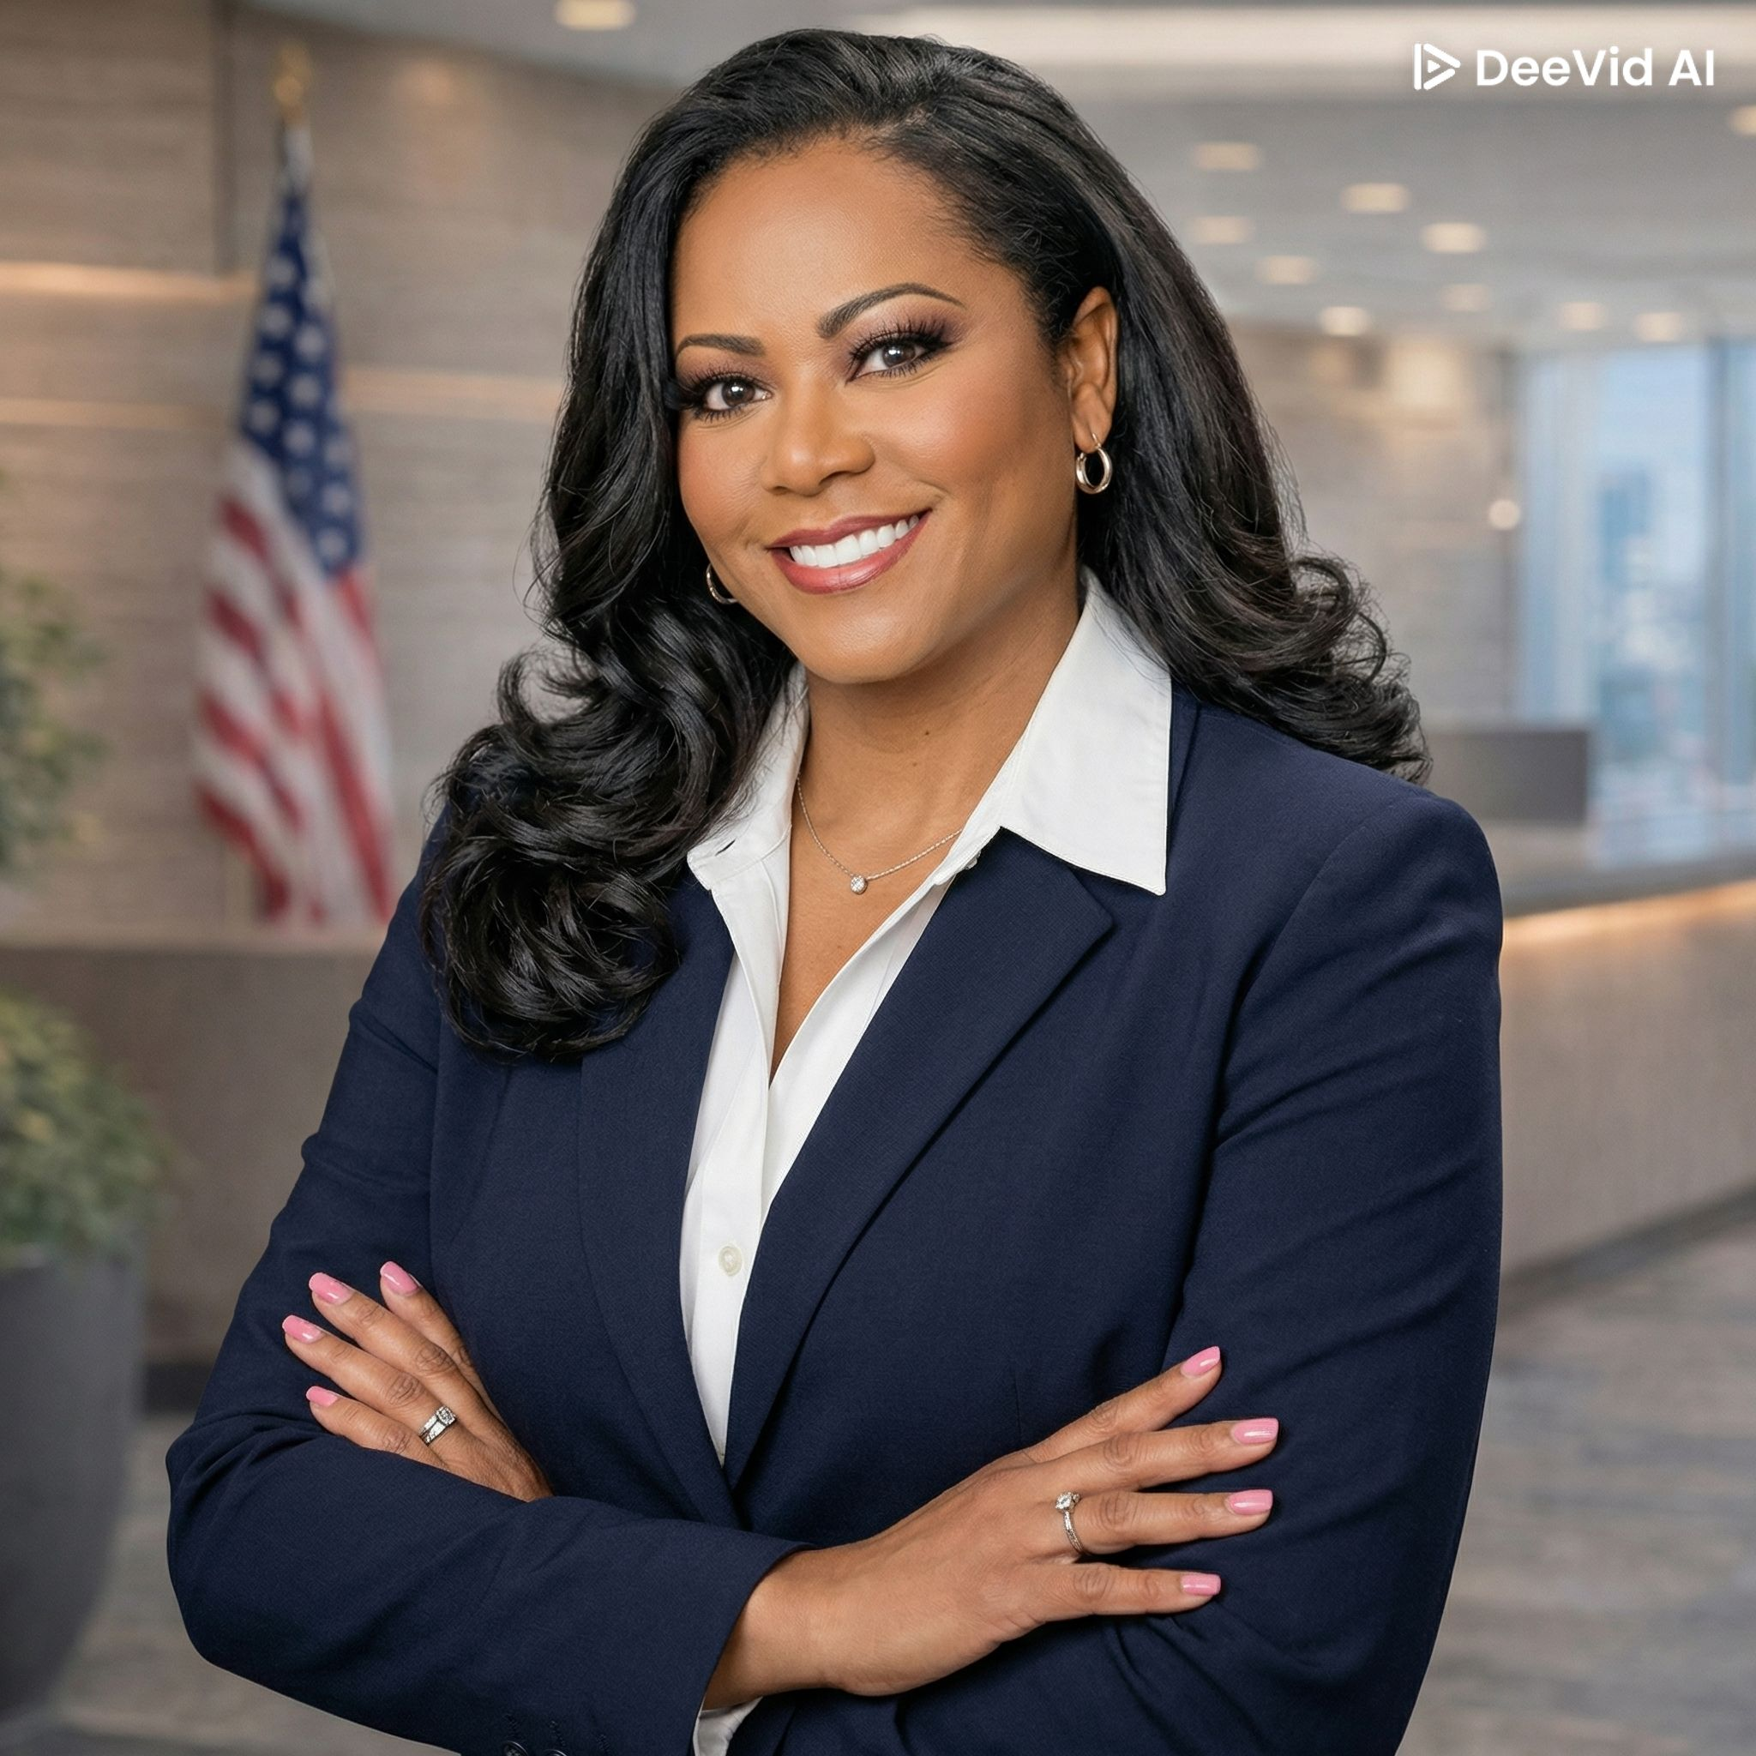 | DR. VIVIAN SMITH-DEL TORO, DBA  Co-Owner & Chief Executive Officer | Owner & Managing Broker  Strategic Operations Executive • Executive Business Coach • Real Estate & Mortgage Leader  📍 Chicago, IL • 📞 (312) 852-8180 • ✉ drvivian@csuiteparadigm.org • linkedin.com/in/viviansmithdeltoro

EXECUTIVE PROFILE

Visionary dual-licensed Realtor and Mortgage Loan Originator with 20+ years of multi-site operational leadership across Real Estate, Mortgage Lending, Hospitality, and Food Service. Doctor of Business Administration with a proven record of building high-performing teams, driving incremental revenue growth, and delivering world-class client experiences. Founder of a global executive consultancy, DEI&B champion, and transformational leader recognized for turning around complex operations and expanding market presence across the U.S. and internationally.

CORE COMPETENCIES

- Impact, Action & Organizational Leadership | - Team Building & Collaborative Leadership
- International Multi-Site Operational Leadership | - Project Management: Scrum/Agile
- Change Leadership & Development | - Commercial Real Estate & Site Selection
- Brand Management & Marketing Strategy | - Business Research & Strategic Analysis
- DEI&B Champion & Culture Builder | - Executive Coaching & Talent Development

EDUCATION

Doctor of Business Administration (DBA) | University of Phoenix | Confirmed 9/30/2020
Master of Business Administration (MBA) | University of Phoenix
Bachelor of Arts (BA) | Michigan State University, East Lansing, MI

PROFESSIONAL EXPERIENCE

American Financial Real Estate & Loans (AFRE) | Co-Owner, CEO & Managing Broker 2014 – Present
Full-service real estate brokerage and mortgage company | IL, IN, NC, SC
- Dual-licensed Realtor and Mortgage Loan Originator — expert in residential, commercial, land development, leasing, and government-funded sales transactions.
- Drives business development, sales strategy, and agent recruitment across multiple states, building a culture of excellence and high performance.
- Leads contract negotiation, housing market analysis, and client advocacy to deliver stress-free, high-value real estate transactions.
- Oversees executive coaching initiatives, lending partnerships, and proprietary credit approval programs to expand client access and agent productivity.
QDOBA Restaurants / Butterfly Equity | Regional Director of Operations 2021 – 2023
$78M region | 8 District Managers, 52 locations, 1,400 team members
- Enlisted by COO as Turn-Around Change Agent; reduced team turnover 100% in 6 months through targeted DEI&B strategy and culture transformation.
- Repositioned regional financial trajectory: Sales YOY +11%, 45% Flow Through for FY22 Budget via disciplined operational execution and SOPs.
- Led 6 remodels, 1 new restaurant opening, 5 franchise sales, and 3 divestitures.
- Delivered quarterly C-Suite and Board of Directors presentations to CEO, COO, CFO, CPO.
Panera, LLC | Director, Area Operating Partner 2018 – 2020
$135M region | 9 District Managers, 89 restaurants
- Achieved 10% sales increase, 5.4% EBITDA YOY, 3 new restaurant openings, and 5 remodels.
- Created 'Building Great Leaders Series' — reduced team turnover from 198% to 90%; management turnover from 48% to 0%.
- Built a Real Estate Investment & Economic Decision Model (PESTELE analysis) for a 5-year 'Real Estate Strategy 2.0,' saving $100M and improving ROI/ROE.
- Ranked #1 company-wide, improving Food Safety Unannounced Audits from 93% to 98%.
ARAMARK | Regional Vice President Designate – New Business 2016 – 2018
$90M contract volume | 35 clients, 90 locations
- Attained 98% client retention via Client Lifecycle Optimization; developed 3 General Managers to District Managers.
- Expanded operations, securing $32M in new Food Service, Catering, and Restaurant contracts.
Sodexo Global | Vice President of Operations & DEI Champion 2011 – 2016
$350M contract volume | 9 District Managers, 105 General Managers, 95 Corporate Chefs, 1,500+ team members
- Recruited by CEO to lead $350M food service, hospitality, and integrated facilities portfolio across 280 locations and 74 corporate clients including 28 Fortune 500 companies.
- Achieved 98% client retention with comp sales growth of 7–11% for 4 consecutive years; improved EBITDA 15% YOY.
- Re-negotiated underperforming contracts achieving 22% profit margin improvement; awarded $43M in new contracts including $10M international (Ireland & India).
- Managed global accounts: Allstate, AbbVie, Bank of America, Capital One, Delta Airlines, Federal Reserve Bank, GE Healthcare, Kraft Heinz, United Airlines, and 50+ additional Fortune 500/1000 clients.
- Chaired Sodexo's 10th Annual Diversity & Inclusion Summit — saved $1M; led DEI consultancy for C-Suite leaders across 70+ contracts.

BOARD LEADERSHIP & CONSULTING

- Founder & Board Chair — C-Suite Paradigm / Global Executive Business Consultants (csuiteparadigm.org) | 2016–Present
- Board of Directors & Vice Chair — Women's Centers International | 2020–2022
- Chief Operations Officers (COO) Business Forum | 2012–2020
- Board of Directors — All Chicago: Making Homelessness History | 2012–2020
- Board of Directors — Chicagoland Chamber of Commerce; Chairperson, Workplace Well-Being Committee | 2013–2015

American Financial Real Estate & Loans • amfinancialre.com • (312) 852-8180 • drvivian@csuiteparadigm.org

